**Project Planning Phase**

**Project Planning Template (Product Backlog, Sprint Planning, Stories, Storypoints)**

| **Date** | **8 november 2022** |
| --- | --- |
| **Team ID** | **PNT2022TMID07543** |
| **Project Name** | **Visualizing and predicting heart disease using data analytics** |
| **Maximum Marks** | **8 Marks** |

**Product Backlog, Sprint Schedule, and Estimation (4 Marks)**

**Use the below template to create product backlog and sprint schedule**

| **Sprint** | **Functional Requirement (Epic)** | **User Story Number** | **User Story / Task** | **Story Points** | **Priority** | **Team Members** |
| --- | --- | --- | --- | --- | --- | --- |
| **Sprint-1** | **Registration** | **USN-1** | **As a user, I can register for the application by entering my email, password, and confirming my password.** | **4** | **High** | **T.Kowsikamani** |
| **Sprint-1** | **Registration** | **USN-2** | **As a user, I will receive confirmation email once I have registered for the application** | **3** | **High** | **R.Gowri priya** |
| **Sprint-1** | **Login page** | **USN-3** | **As a user, enter the username and password which is already existing** | **3** | **Medium** | **S.Akarsana** |
| **Sprint-2** | **Checking 13 required inputs to analyse** | **USN-5** | **As a user, we can know about body condition** | **10** | **High** | **M.Keerthana** |
| **Sprint-3** | **Detecting pressure,sugar,cholestrol** | **USN-6** | **Using sphygmomanometer can detect pressure** | **12** | **High** | **T.Kowsikamani, R.Gowri priya** |
| **Sprint-4** | **Detecting heart disease** | **USN-7** | **Here doctor needs to update the condition of patients heart** | **9** | **High** | **S.Akarsana, M.Keerthana** |

**Project Tracker, Velocity & Burndown Chart: (4 Marks)**

| **Sprint** | **Total Story Points** | **Duration** | **Sprint Start Date** | **Sprint End Date (Planned)** | **Story Points Completed (as on Planned End Date)** | **Sprint Release Date (Actual)** |
| --- | --- | --- | --- | --- | --- | --- |
| **Sprint-1** | **8** | **6 Days** | **24 Oct 2022** | **29 Oct 2022** | **22** | **29 Oct 2022** |
| **Sprint-2** | **1** | **6 Days** | **31 Oct 2022** | **05 Nov 2022** | **10** | **05 Nov 2022** |
| **Sprint-3** | **2** | **6 Days** | **07 Nov 2022** | **12 Nov 2022** | **12** | **12 Nov 2022** |
| **Sprint-4** | **1** | **6 Days** | **14 Nov 2022** | **19 Nov 2022** | **9** | **19 Nov 2022** |

**Velocity:**

Imagine we have a 10-day sprint duration, and the velocity of the team is 20 (points per sprint). Let’s calculate the team’s average velocity (AV) per iteration unit (story points per day)

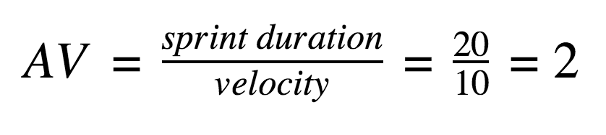

**Burndown Chart:**

A burn down chart is a graphical representation of work left to do versus time. It is often used in agile[software development](https://www.visual-paradigm.com/scrum/what-is-agile-software-development/) methodologies such as [Scrum](https://www.visual-paradigm.com/scrum/scrum-in-3-minutes/). However, burn down charts can be applied to any project containing measurable progress over time.

